-o- Glee Club -o-
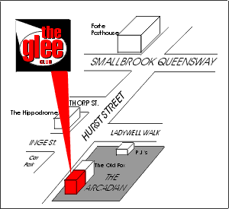 | -o- BIRMINGHAM -o-  Hurst Street  Birmingham  15 yards from Hippodrome Theatre,  above O’Neils, the English owned Irish“theme pub” that resembles no Irish bar any of us have ever seen!  Wednesday £7 / £4 nus (run Oct - end March)  Thursday £7 / £5 nus / £7.95 with Balti  Friday £10.50 followed by Disco  Saturday £12.50 followed by Disco  Prices may change for tour or holiday shows
The bad news...
On Wednesdays, Thursdays and Fridays we do not accept single or predominantly single sex parties of more than 8 people without a Behavior Bond.
On Saturdays we do not accept single sex parties of over 5 whatsoever !!!
Call the office for details.

